ROBOTIC EYE DRAWINGS TREE – V5

1. V5-DRAWINGS TREE.DOCX = This file!
2. 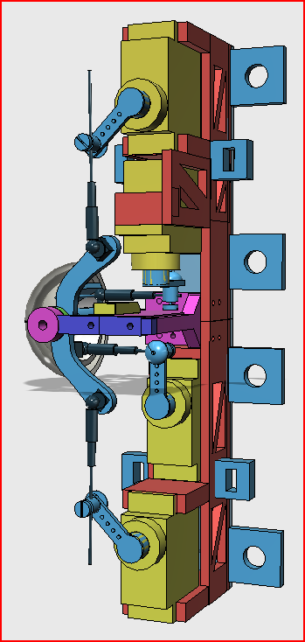Version 5 Complete.123dx – full model with servos, servo arms, EZ connectors, ball joints and pins, camera. Also has tie points for zip strip attachments & mounting tabs, and camera mount and camera cable down improvements. Eyelid control arms are splined in this version.
   1. V5 Parts Master.123dx stripped down version of above. This version has one side printable parts only

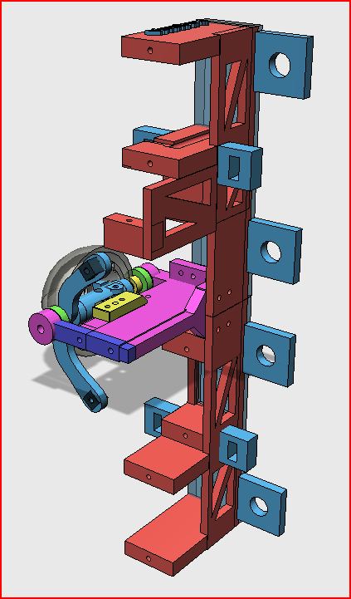

* + 1. Frame Parts.123dx
       1. Frame, Top.123dx

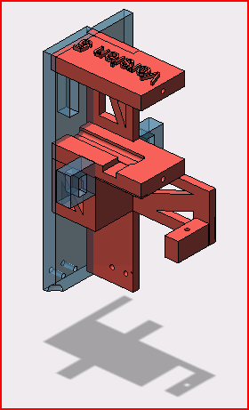

* + - 1. Frame, Bottom.123dx – NOT SHOWN
    1. Side Frame Parts.123dx

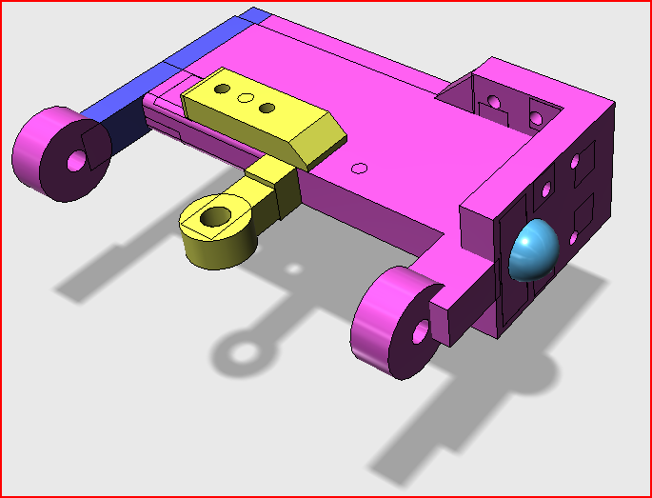

* + - 1. Side Frame.123dx

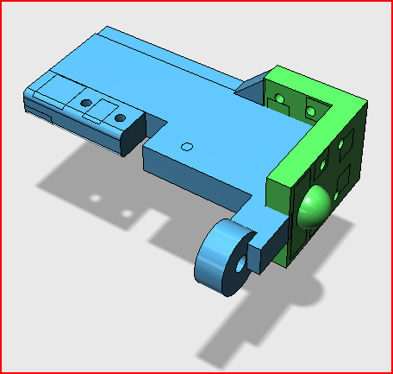

* + - 1. Side Frame, Outer Pivot.123dx

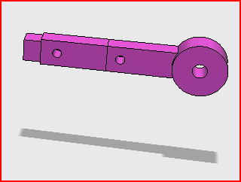

* + 1. Eye Parts.123dx

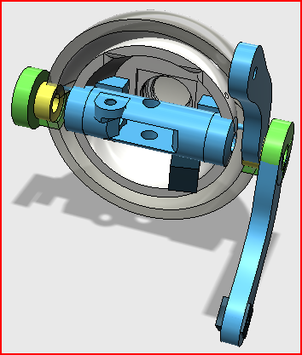

* + - 1. Eyeball.123dx

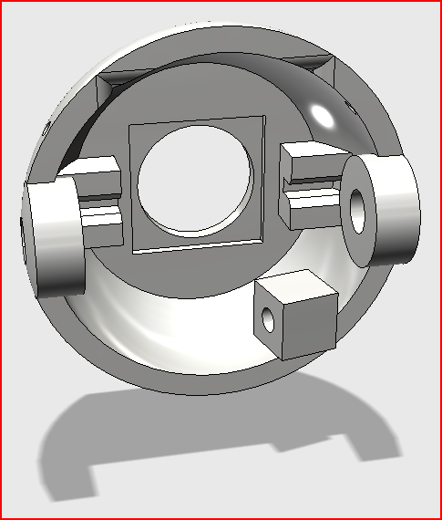

* + - 1. Eye Cornea.123dx

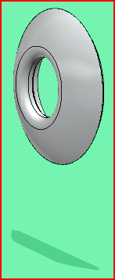

* + - 1. Eyeball Pivot.123dx

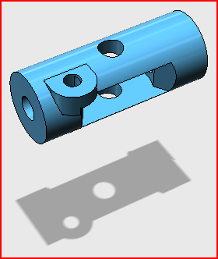

* + - 1. Eyeball Pivot Post.123dx

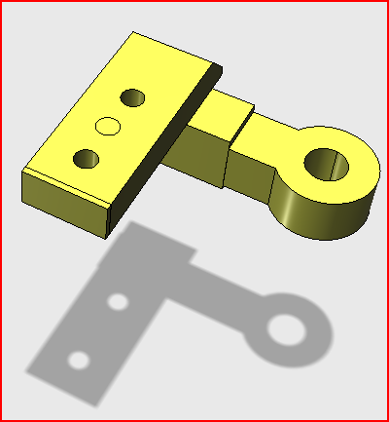

* + - 1. Eyelid, Upper.123dx

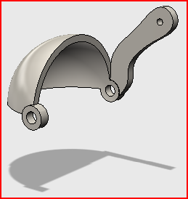

* + - 1. Eyelid Lower.123dx

